**Actoday Flood Index Insurance Bangladesh report Y3Q4**

Led by Beth Tellman. Support for analysis includes students (Max Goodman), interns (Mitchell Thomas, Tejit Pabari, and Julia Samson) and staff (Yohana Tesfamariam, Shammunul Islam, Igor Komyakov, Melody Braun).

**Timeline (from the proposal):**

|  |  |  |  |  |  |
| --- | --- | --- | --- | --- | --- |
| **Objective** | **Jan -Mar 2020** | **April-June 2020** | **July-Sept 2020** | **Oct-Dec-2020** | **Jan-Mar 2021** |
| **1.Case study selection based on damage data quality and availability** |  |  |  |  |  |
| **2. Time series processing for flood indicators** |  |  |  |  |  |
| **3. Time series processing for damage data** |  |  |  |  |  |
| **3. Key performance indicators of flood proxy data, results categorized by flood type** |  |  |  |  |  |
| **4. Virtual workshops/trainings** |  |  |  |  |  |
| **5. Publish results** |  |  |  |  |  |

**Progress in Q3**

In quarter 3, we are at the midpoint of time series processing for all flood indicators and damage data. Status updates for each variable are shown in tables 1 and 2. This quarter, we focused on processing water level data, developing a Sentinel-1 and passive microwave timeseries, and setting up initial training and test of the media times series. Preliminary results for each are shown below. We also produced initial bad years insurance analysis with support from Mike Steckler’s Bangladesh class. We are turning that report into a presentation with our partners. We also decided to focus the study in Northern Bangladesh, in the regions that experience river erosion, monsoon, and flash flooding.

*Water Levels*

We obtained 304 river water level stations around the country, from a collaborator, Mike Steckler, a research professor at Lamont. These data are from 2003 to about 2015, although we have station data for an additional location for 2017. We have written r-script and python scripts to generate graphs of water level data for any station in the country. Figure 1 shows the location of the stream gauges, and an example of a daily graph with water levels. Years beyond 2015 are needed, because both the media data and the Sentinel-1 data are best in years after that time. We continue to wait for the government to sign a Letter of Agreement for us to obtain additional data.

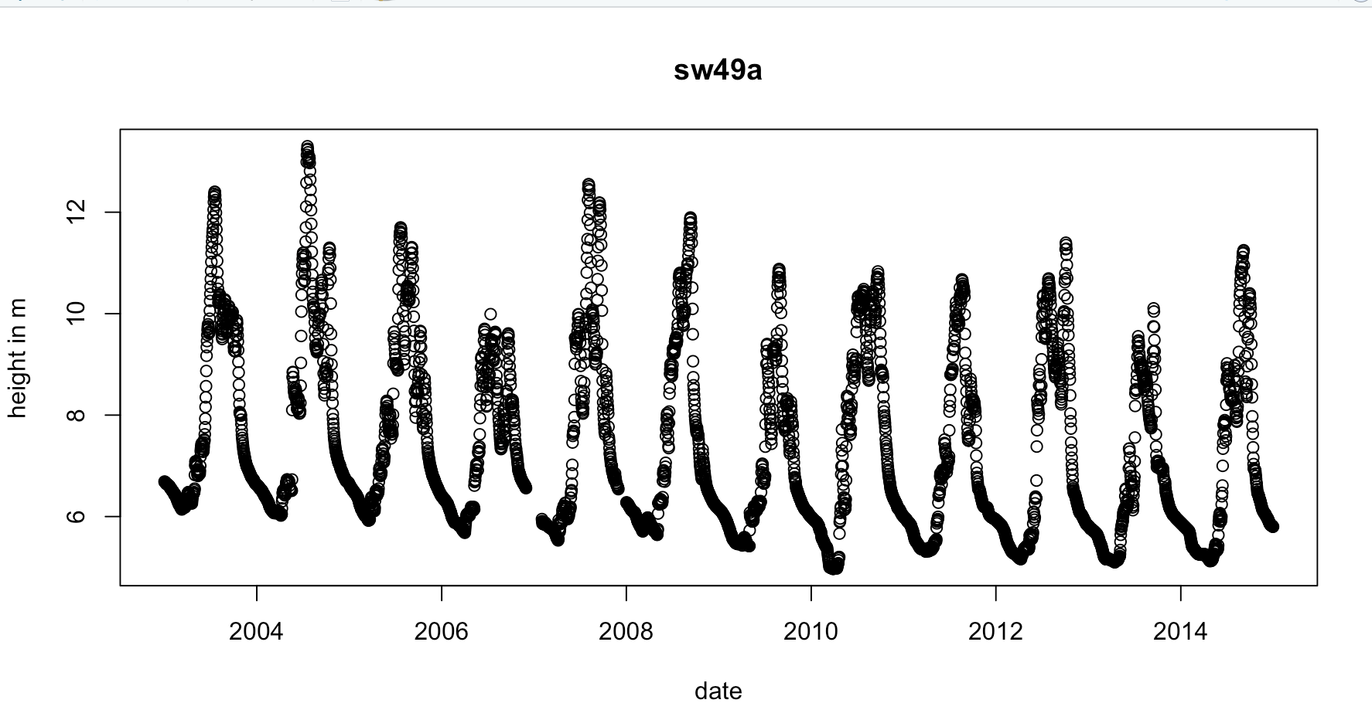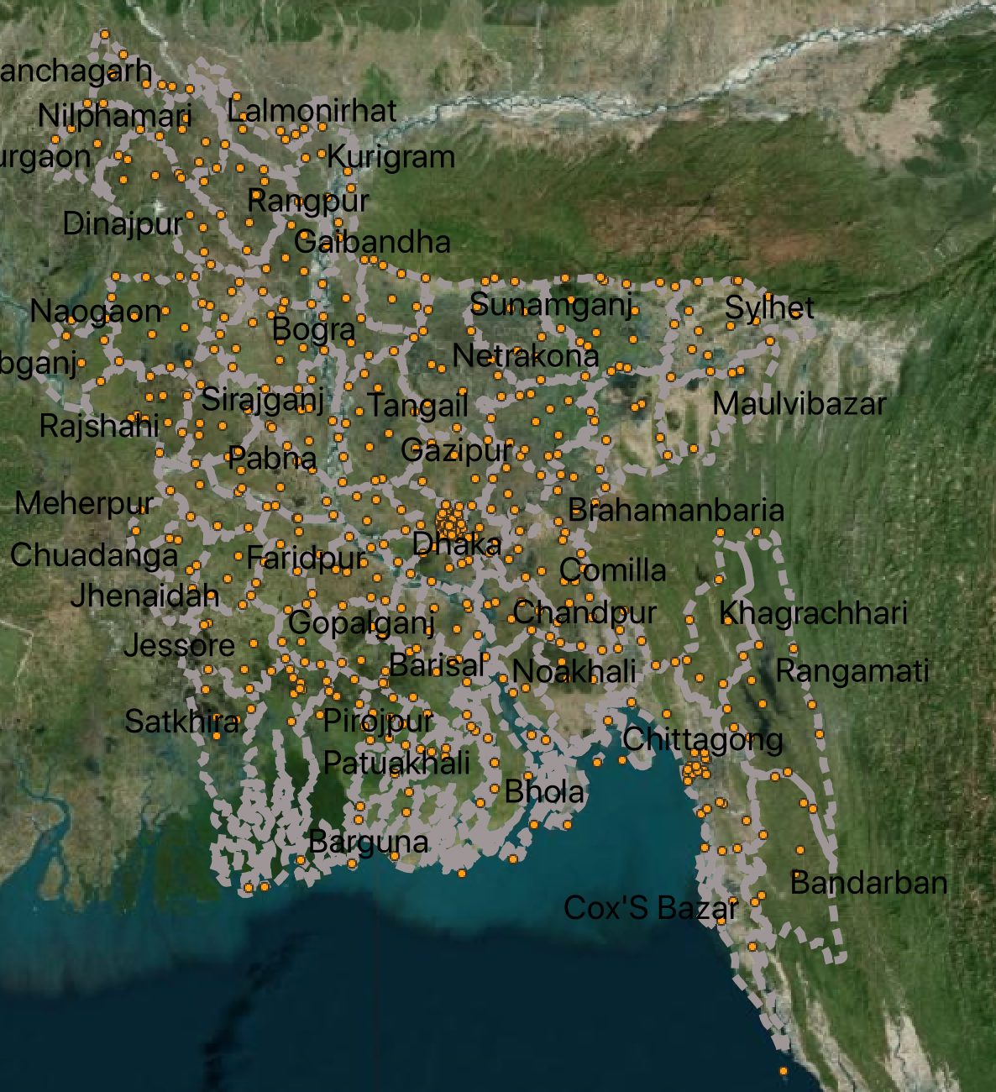

**Figure 1**. Map of stream gauge locations (in orange, left) and a water level time series graph (right) of water height in meters at a daily time step for station sw49a.

*Sentinel-1 events*

We developed an algorithm to map flood events by modifying an algorithm from a published paper for the Sentinel-1 satellite (DeVries et al 2020) in Google Earth Engine. This algorithm can be run for any data, anywhere in the world- we have made specific adjustments for it to function in Bangladesh. An example of this map is provided in figure 2. At the request of FFWC, we shared a Geotiff of these data, with a 3 page metadata document explaining the algorithm via email. We also exported inundated area for 11 upazilas in the Sirajganj district for the 2015 and 2017 flood events, and compared inundated area (defined with different baseline. FFWC have now requested our help in using these flood maps to better define how they set “danger levels” in these regions of Bangladesh in the future. Danger levels are water levels set on each stream gauge (from Figure 1) which when crossed, are used to alert local authorities and populations of a large flood event. During a call with FFWC, they described to us that sometimes the danger levels are set incorrectly, resulting in farmers failing to harvest fields in time, or authorities not realizing a damaging flood could occur.

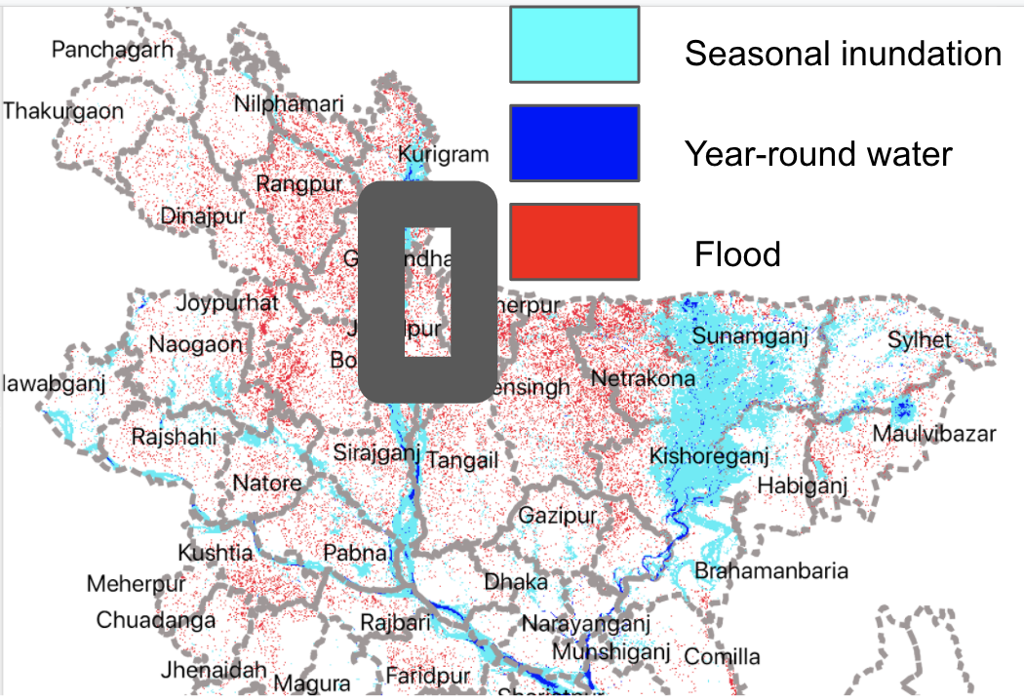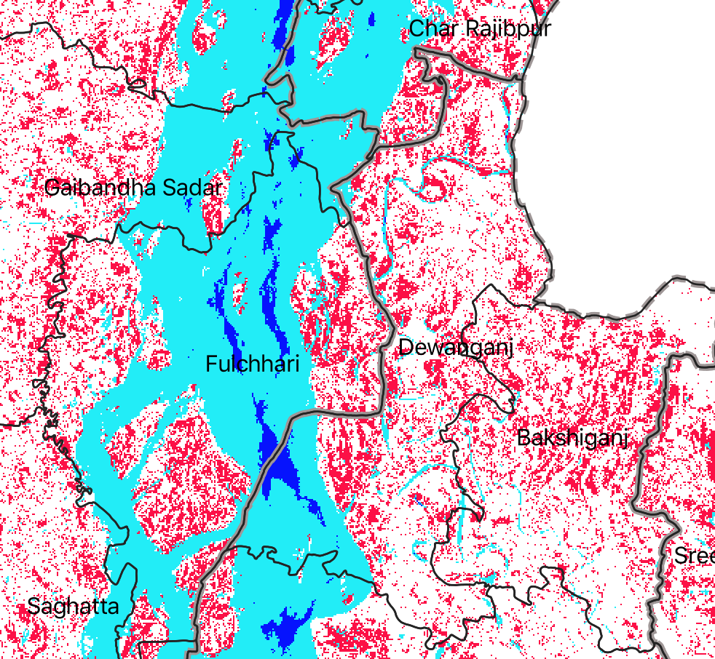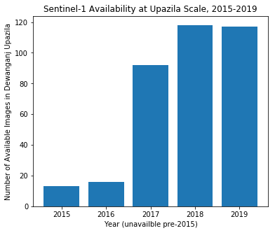

**Figure 2.** Example flood map with prior inundation in light blue, flooding in red, and permanent water in dark blue for August 2017 from the Sentinel-1 algorithm

*Sentinel-1 time series*

This quarter we began to improve the Sentinel-1 algorithm so that it could be run for every available Sentinel-1 image over time, not just for a set date of flood events. We found that while the Sentinel-1 satellite was launched in 2014, it was not until 2017 that regular observations became available at 6-12 day intervals (See Figure 3). We correct several errors in the algorithm, for example, but ensuring it ran flood detections in both ascending and descending modes. We also began to compare the Sentinel-1 flooded area time series to water level data (Figure 4). We find reasonable congruence between flood area peaks and water levels. More work will be done in Y4Q1 to optimize the algorithm further, assess its accuracy, and run inundation area statistics for all upazilas in the study area in Northern Bangladesh.

**Figure 3.** Number of images available in a select upazila per year from Sentinel-1 in Bangladesh.

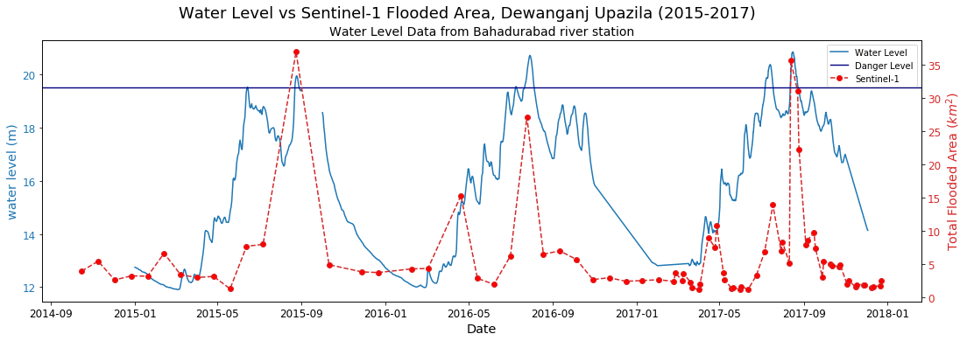

**Figure 4.** Flooded area from Sentinel-1 compared to water level, 2014 to 2017. In a select Upazila.

*Passive Microwave*

The second radar dataset we are using is passive microwaves. These sensors importantly can detect water through clouds, and have a longer time series than Sentinel-1. We worked with Lamont researcher Marco Tedesco to procedure this dataset. To produce this dataset, data from the Special Sensor Microwave /Imager (SSM/I) and the Special Sensor Microwave Imager/Sounder (SSMI/S) at Ka- band (37 GHz), horizontal polarization (H-pol.) collected during the ascending (A) pass of the satellite between 1992 and 2019 have been used. The satellite images are available through the NASA MeASUREs project (information about the data are available here<https://nsidc.org/data/nsidc-0630/versions/1>) at the spatial resolution of 25km and 3.125km (produced using a new gridding algorithm based on the antenna gain function called rSIR technique, Brodzik et al., 2018). Passive microwave data have been used to monitor and map large flood events due to their sensitivity to the presence of water over land (the brightness temperature signal decreases as the amount of water increases) and several algorithms have been proposed. A variation of the algorithm proposed by De Groeve and Riva (2009) has been applied. The basic assumption is that close pixels have similar land surface properties (affecting the brightness temperature). The measured (M) brightness temperature value of a pixel is considered as the combination of water and land brightness temperature contributions (proportionally to the fractional area). We have a metadata document describing the algorithm and data files, and one matlab file for each year, from 1992-2019. The data we have currently is a binary pixel at 3.125km resolution, with a value of 1 indicating a flood is present and 0 indicating no flood is present. This algorithm is very sensitive to the threshold defining what is a flood, and are attempting to calibrate it further. This dataset led to important discoveries already.

In Figure 5, we show the increase in flooded area in March-April, without a subsequent increase in water level. With the help of Michael Steckler and Chris Smalls (Lamont researchers), we were able to determine this is a time of irrigation during rice cropping from ground water pumps and field photos. We confirmed this in ground water pump maps (figure 6), and analysis of the phenology (figure 6) and visual inspection of landsat imagery (figure 7).

We await the fractional flooded area time series from Dr. Tedesco, and we will assess the accuracy of this product using high resolution Planetscope imagery (3-5m resolution). We continue to have weekly meetings with him to improve the algorithm and time series further.

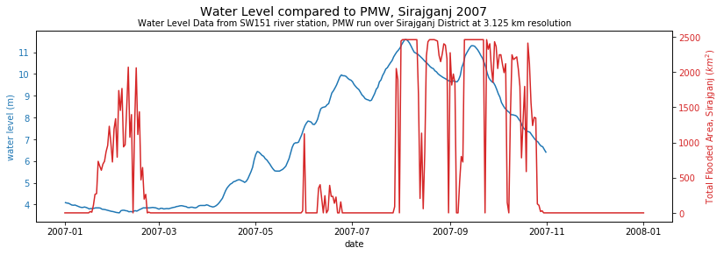

**Figure 5.** Flooded area from passive microwave sensors, compared to water level in 2007. In a select district.

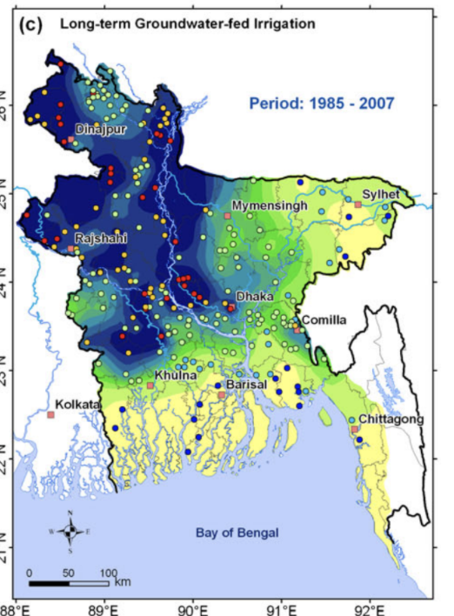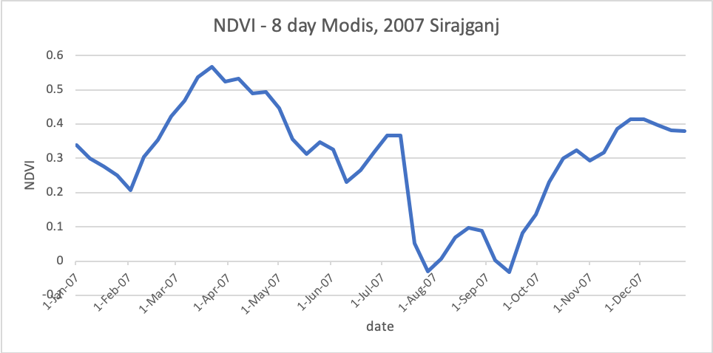

**Figure 6.** Groundwater pumping map from Shamsuddua et al 2011, left Blue indicates more extensive groundwater pumping. Top right, NDVI graph over Sirajganj, showing a drop in NDVI in February, indicating the presence of water.

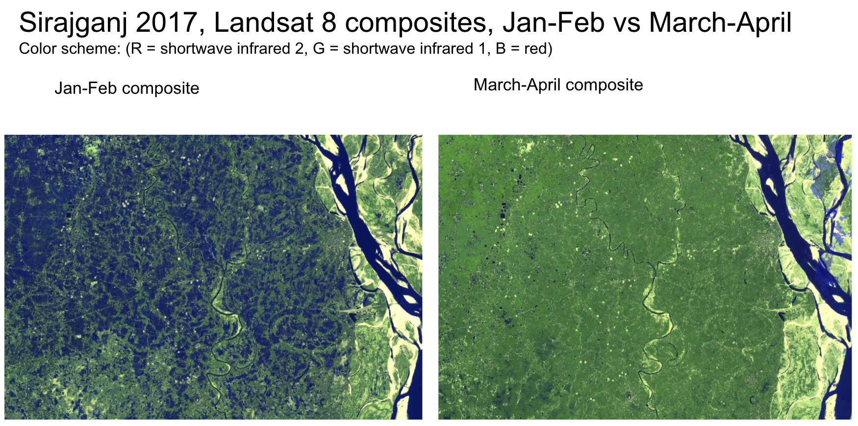

**Figure 7.** Irrigation of agricultural areas during February in Sirajganj (blue area, for water, left), a signal which is being picked up strongly by the passive microwave sensor (which is very sensitive to wet soils). The same region is shown on the right, when the water is no longer present in fields.

*Landsat Monthly Water extents*

We were hoping to use an existing surface water product as a flood proxy. The Landsat-derived JRC monthly surface water data (Pekel et al 2016) displayed major flaws when examined over Bangladesh. In the year 2007, every monthly raster of surface water in Sirajganj during the monsoon season displayed either major detector striping, omitted swaths, both, or no data at all (Figure 9). Consequently, the time series of total pixels representing water in Sirajganj showed erratic behavior determined by varying data quality rather than the expected seasonal curve. In fact, for most years examined, monthly flooded area appeared to fall during the rainy season and rise during the dry season. We concluded that cloud interference was likely causing these inconsistencies. JRC yearly water class, which presents yearly maps of permanent and seasonal water based on Landsat data, was also examined, and also found to be of suspect quality within the study area. The time series of JRC yearly seasonal water in Sirajganj from 2007 to 2018 displayed local maxima in 2008 and 2016 rather than 2007, 2015, and 2017, when large and damaging floods were reported in the region (Figure 8). We concluded that Landsat-derived estimates were not reliable for reporting flooding extent in this application.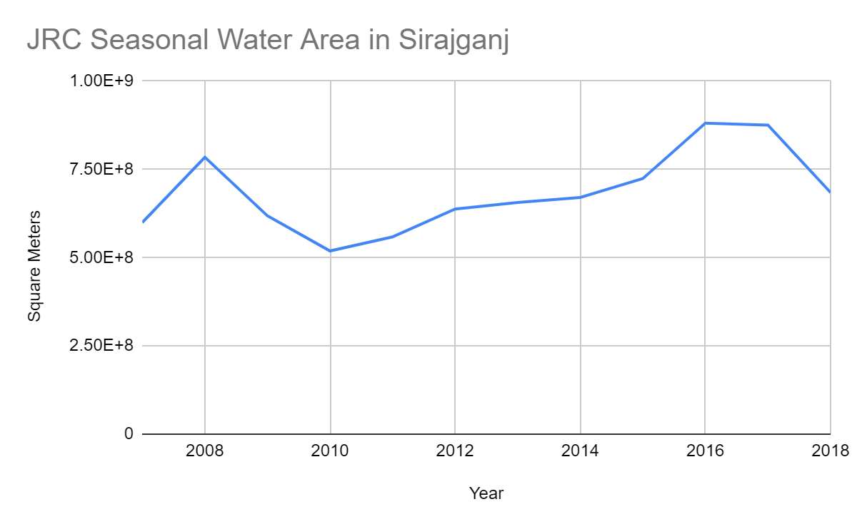

**Figure 8.** Annual inundated area in Sirajganj reported by JRC.

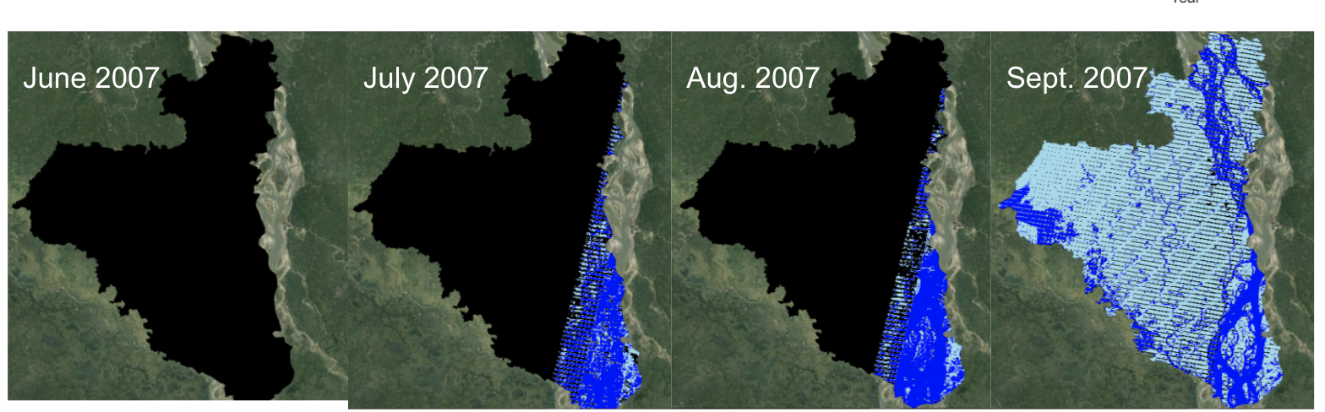

**Figure 9.** Landsat JRC monthly water detections. Black areas indicate no data (due to clouds).

*NLP of Media*

This quarter we began the natural language processing algorithm to automatically identify media articles. We scraped 7,090 news articles using the New York Times API and other national newspapers (using SERP API). We are using 10 news sources currently, english language only. We wrote a python script to extract the text for each article. We used a program called Tagtog to annotate articles. Each article is annotated by Shammunul and reviewed by Beth. We have annotated so far 982 articles, tagging if the article was about a flood event, what type of event, where it was located, and all damage statistics (crop loss, fatality, household loss, and more). All text is converted to features using tf-idf (term frequency–inverse document frequency, a numeric statistics commonly used in text mining), and then articles are classified as either “is a flood event” or “non a flood event” (Figure 10).

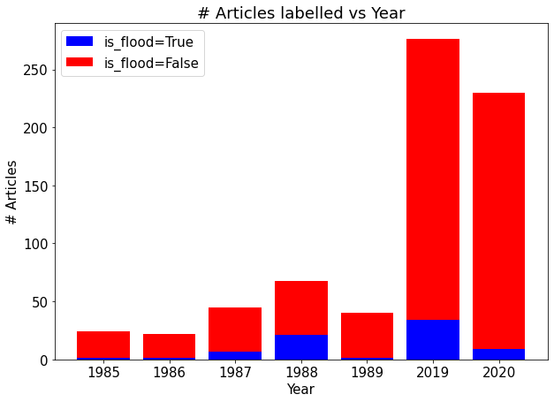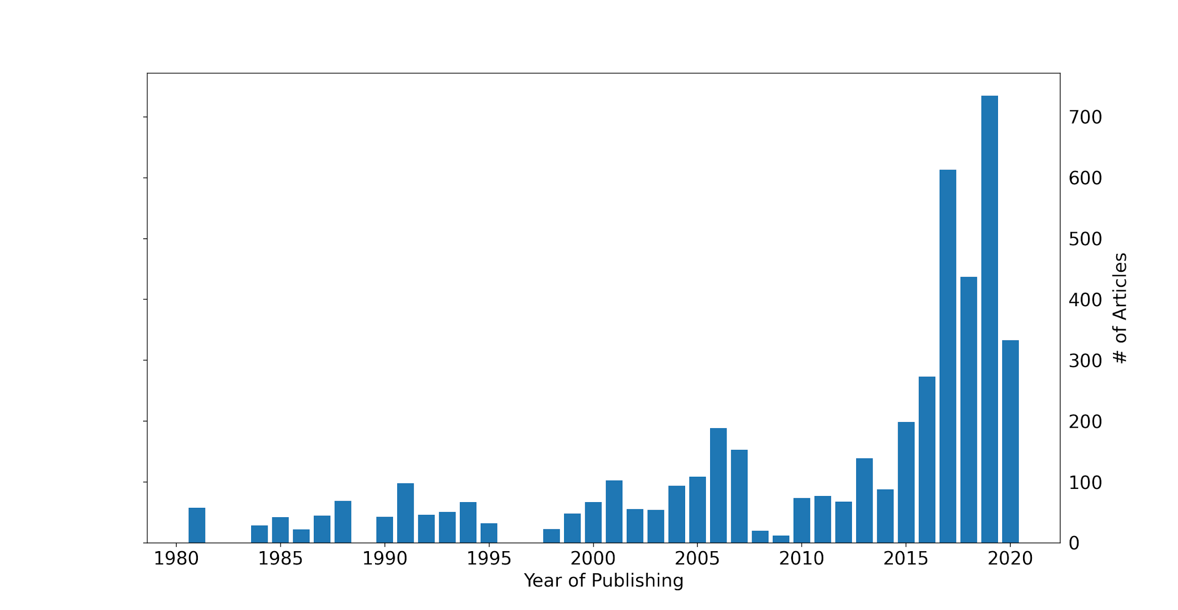

**Figure 10.** Time series of articles scraped using the word “flood” from over 10 sources (left). Articles manually annotated so far (n=708) right.

Accuracy of the classifier is currently 85%, with most misclassification currently resulting from false positives (the algorithm identifies an article as a flood event, which is not a flood event). We are increasing our number of training articles to attempt to improve the classifier, and may move to deep learning classifiers (such as BERT) to improve performance. Encouragingly, the time series seems to classify and identify flood articles mainly during the monsoon season (June, July and exhibit correct seasonality, Figure 11).

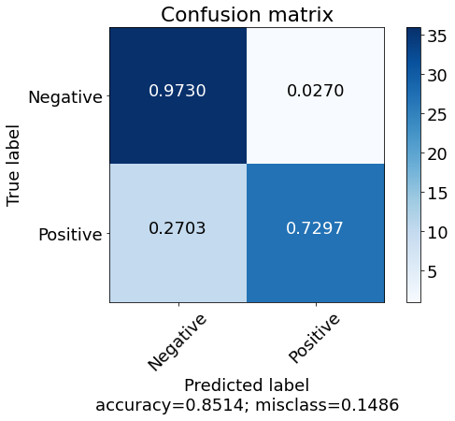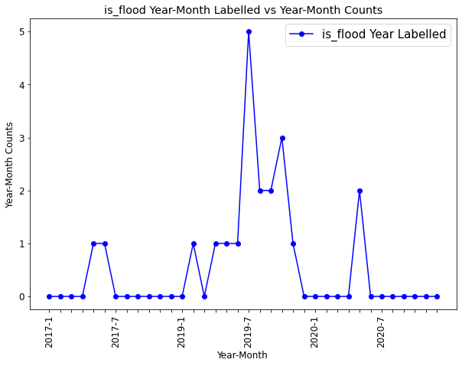

**Figure 11.** Right, Tradeoff in accuracy, precision, false positives, and false negatives for the initial LinearSVC classifier. Left, time series of media articles per month, 2017-2020.

*Student Report*

The Columbia University Sustainable Development Capstone Workshop students were responsible for exploring flood proxies and validation datasets. The students identified time series data and then conducted cross-comparisons to exercise the validation process and evaluate any correlations within the data sources. For this project, stream gauge data, satellite data, and discharge were validated using damage data (agricultural, fatalities, people affected), expert elicitation, and bad flood years reported by farmers.

From the data sources obtained, the following figures will showcase the cross-comparison and validation process results thus far for the districts of Kurigram, Gaibhandha, Bogra and Sirajganj.

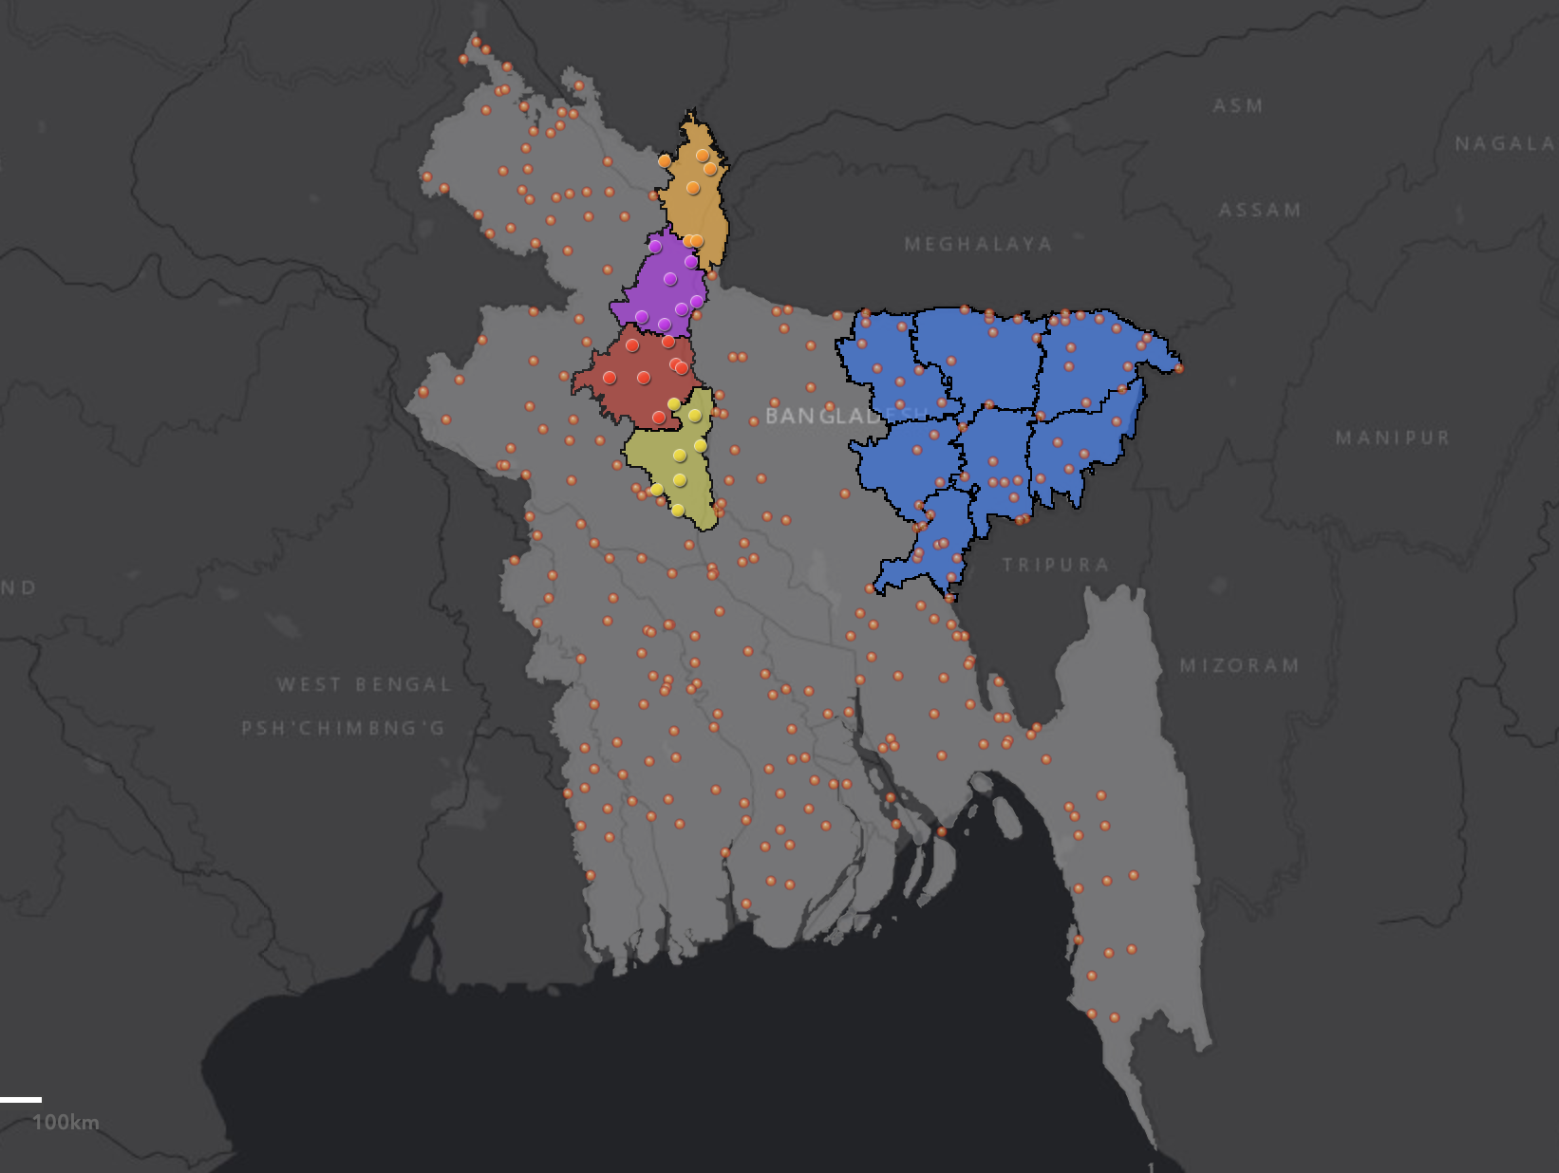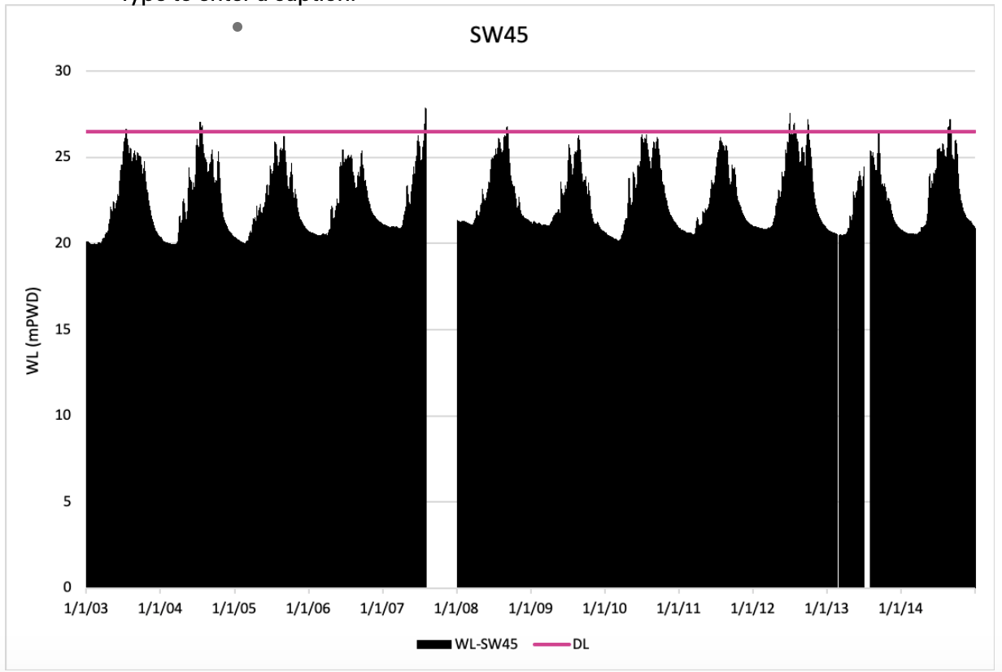

**Figure 12.** Stream gauge locations map highlighting the areas of focus (Kurigram - Orange, Gaibandha - Purple, Bogra - Red**,** Sirajganj - Yellow, Hoar Region - Blue) (left) and an example of a stream gauge water level plot in Kurigram (right).

*Worst 8 years based on the Stream Gauge Data Water Levels*  
In this quarter using the stream gauge data provided we looked at the districts that are currently the main focus for index insurance projects for floods. By plotting the stream gauges available in each district, the following worst 8 year of floods were identified and visualized for Aus, Aman and Boro in each district (Figure 13.)  
There were many limitations to the stream gauge data such as, the data only being available from 2003 - 2014, most stream gauges did not have danger levels as well as some gaps in the data itself.

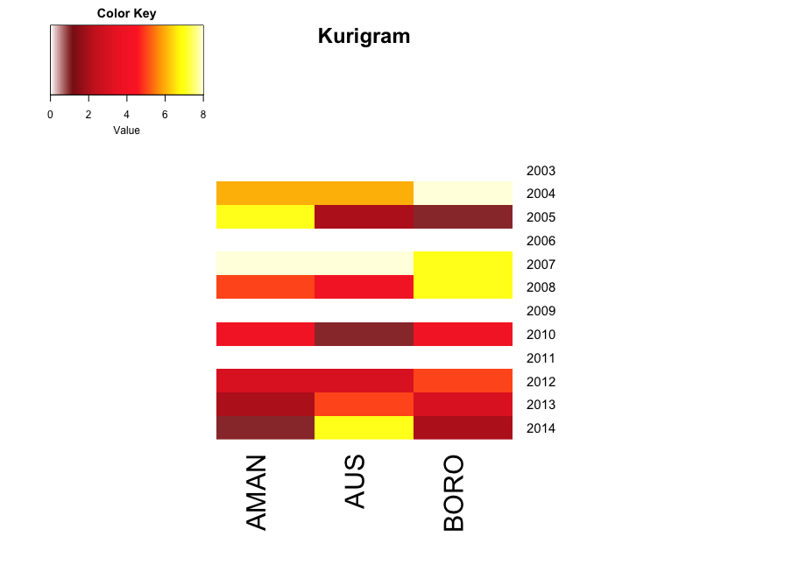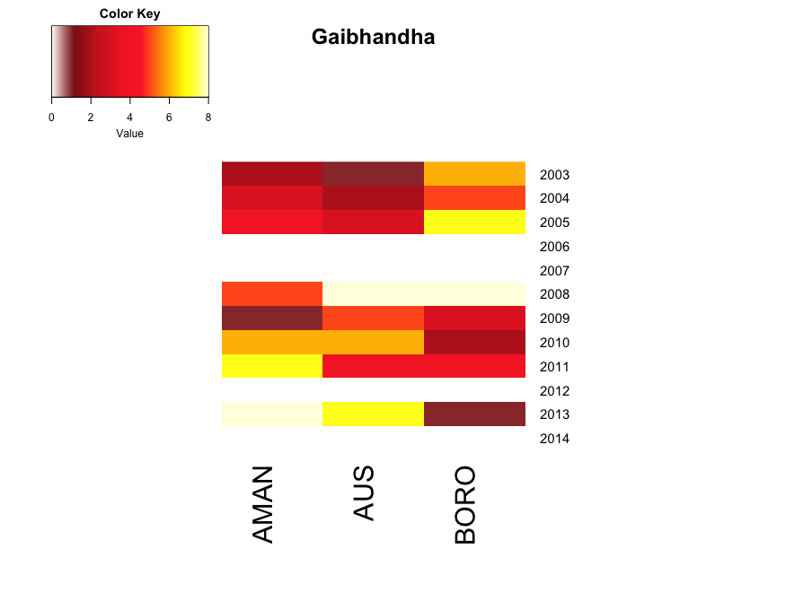

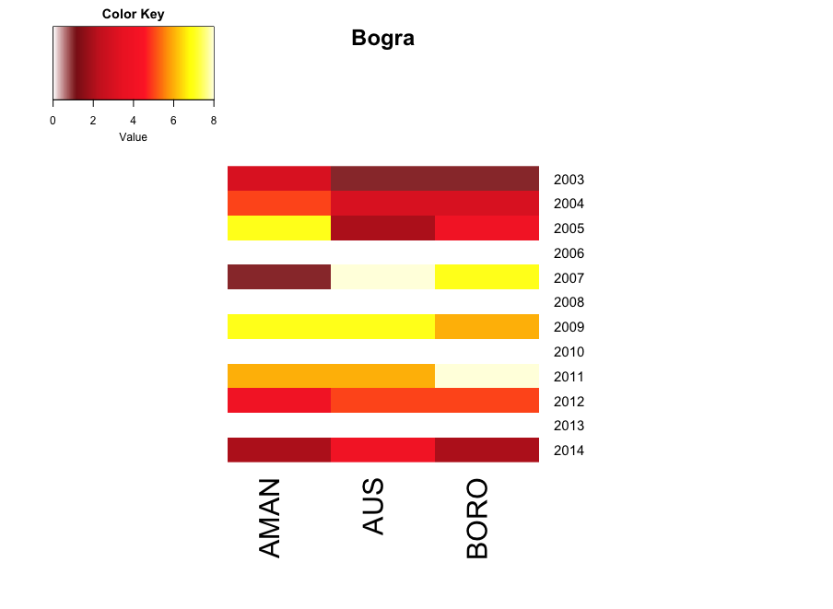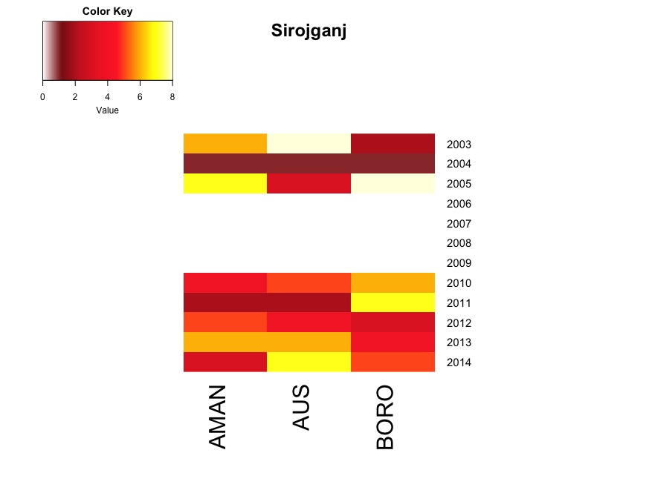

**Figure 13.** Ranked worst 8 years of floods by district for Aus, Aman and Boro derived from stream gauge data

*Cross-comparison the worst 8 years using Agricultural Damage Data*

Agricultural damage data was hard to find because there was no cohesive way of recording agricultural damage data for flood events. We came across a few D-forms and in the next quarter it will be extremely useful to obtain these forms in order to conduct a more thorough and cohesive analysis by having one source. For this quarter our agricultural damage data mainly relied on the damage data provided by BBS Agricultural Statistics Books 2012-2014 and Flood Situation Reports conducted by Red Cross, Nirapad, and some D forms when accessible as our sources.

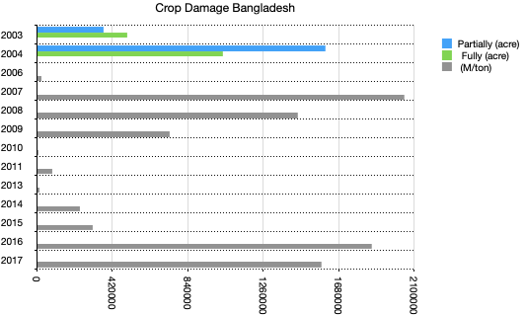

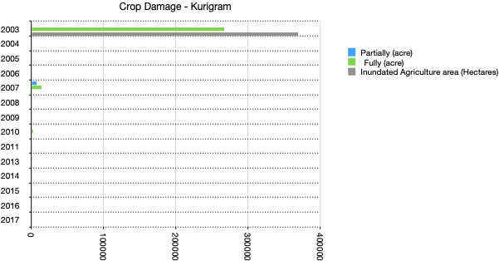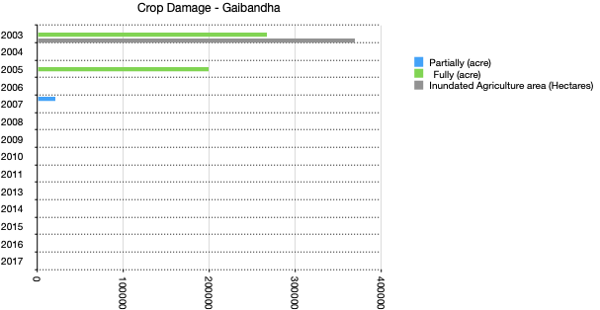

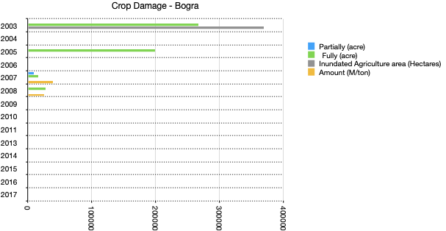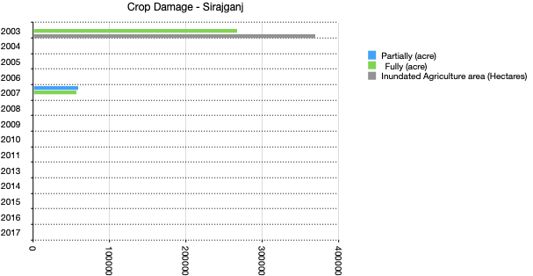

**Figure 14.** Agricultural damage data for recorded years at district and national level

*Cross-comparison the worst 8 years using EM-DAT (Emergency Events Database)*

EM-DAT is the emergency events database that contains core data for mass disasters. In this instance we looked at the flood data available over Bangladesh.   
The data in the EM-DAT database is compiled from various agencies such as, non-governmental organizations, press, UN agencies, research institutions etc. The following Figure 15 shows the years that were identified in the EM-DAT database for flood years in Bangladesh and in the districts of interest.

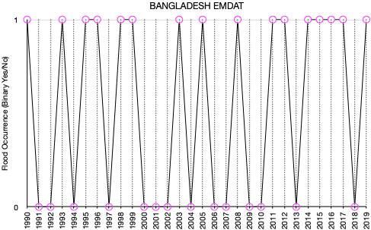

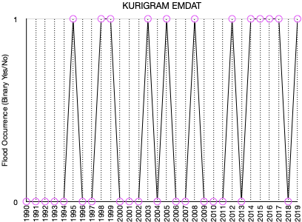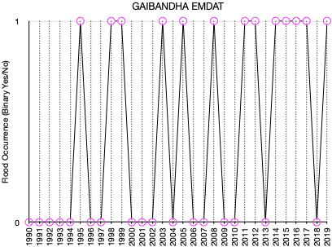

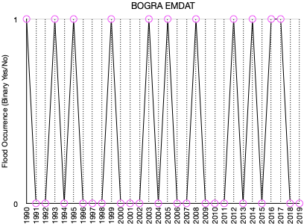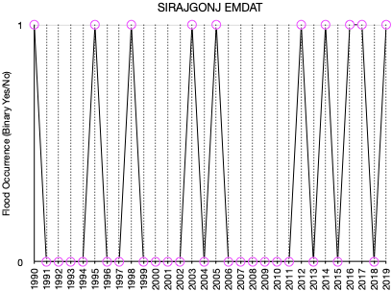

**Figure 15.** EMDAT recorded flood years at country and district level

*Cross-comparison the worst 8 years using Expert Elicited Data*

To strengthen the source of flood years the students sent ODK (open data kit) forms to experts in Bangladesh with questions designed to obtain district level flood years. The results are as follows on Figure 16 for the districts in question.



**Figure 16.** ODK forms recorded flood years at district level

Unfortunately, although some data from Twitter and Sentinel-1 was available it did not overlap with the stream gauge years.  
Through these different data flood years cross checking process, there was ~21% congruence for Kurigram, 29% congruence for Gaibandha, 29% congruence for Bogra and 25% congruence for Sirajganj between the years identified through the stream gauge data analysis and the other data sources (agricultural damage data, EMDAT, expert elicited data). This would definitely be strengthened by having a longer time series and being able to use other sources such as satellite data and having better local agricultural damage data access.

**Data:**

**Table 1. Potential Flood Indicators Status**

|  |  |  |  |
| --- | --- | --- | --- |
| **Type** | **Source** | **Spatial,Temporal Resolution and Record Length** | **STATUS** |
| Water Level | Bangladesh Water Development Board, maybe BUET has some, Mike Steckler has shared 304 gauges 2003-2015 for most areas, some have 1998 data | various | R code written to process water level data from Mike Steckler, but awaiting government to sign LOA to access data from 2015-present needed for validation |
| Rainfall | ENACTS (IRI data library) | .05 degree, daily, 1971-2017 | Have not begun |
| MNDWI from optical data | Needs to be made, could use Sentinel-2, Landsat, could use Du et al (2016) for MNDWI (Modified normalized difference water index) | ~every 2 weeks 1984-20 (30m), then every 3 days (30m- fusing Sentinel-2 and Landsat) 2017-present | AWAITING COLLABORATION WITH IMWI BEFORE DEVELOPING |
| ~~Monthly surface water~~ | ~~JRC Water occurrence dataset (Pekel et al 2016) using Landsat~~ | ~~30m, monthly, 1985-2016,~~ | Determined to be inadequate due to cloud cover |
| Satellite: Radar Backscatter | Beth +students developed algorithm in google earth engine that exports flooded area per upazila- can be run country wide. | 10m, every 6 days, 2017-present, scattered days 2017-2014 | Algorithm works, but optimization, parameterization, and validation still required. Determining if adjustments to account for flooded vegetation are required |
| Satellite: Microwave Emissivity | Brightness temperature, working with Marco Tedesco, Lamont, to translate to surface water fraction | **25km** (3km enhanced product), twice daily 1992- present | 3km product 1992-2015 delivered, awaiting 2015-present data and fractional flooded area |
| Satellite: Daily surface water | Using MODIS (from Ji et al 2018) | 500m, daily, 2001-2016 | AWAITING COLLABORATION WITH IMWI BEFORE DEVELOPING |
| Satellite: IWMI surface water flood product | 8-day MODIS composite LSWI (Land Surface Water index- Matheswaran 2018) | 500m, 8 days, 2001- present | AWAITING COLLABORATION WITH IMWI- LOA SENT |
| Satellite: Cloud to Street recurrence flood product (inundated area) | Monthly or yearly inundated area using daily Landsat and MODIS (Tellman et al 2019) | 250m and 30m; monthly; 1984-present and 2001-present | MAY NOT BE REQUIRED PENDING IMWI COLLABORATION |

**Table 2. Damage Indicators**

|  |  |  |  |
| --- | --- | --- | --- |
| **Type** | **Source** | **Spatial,Temporal Resolution and Record Length** | **STATUS** |
| Agricultural damage data (estimated from crop area and yield data) | Yield from Bangladesh Bureau of Statistics (BBS), damage estimates from Allaire et al (2017) | 2008, 2012-2015 from BBS, according to Allaire et al 2017 | Very sparse data access to D-forms will be extremely useful |
| fatalities | Bangladesh disaster management Bureau | Country level since 1998-2007 (Hassan from Red Cross Sent- still need better) | Some Data in excel sheets is available but not enough to cover all years |
| people affected | Bangladesh disaster management Bureau | Some from BBS- and Em-date need more | Some Data in excel sheets is available but not enough to cover all years |
| Media reports- analyzed with Tejit (Intern for summer 2020 with Eugene Wu) | Analyst trains NLP algorithm) from news media local papers to extract flood event (month-year) and damaging event and variables (people affected, agricultural and infrastructure losses, etc) | Depends on digital archives of papers, but usually daily, since about 1987, aprox 7,000 articles across 10 media sources | 982 annotated media articles, accuracy currently 85% on 74 test articles (trained in 631 articles). Using SVM algorithm will change in BERT if no improvements. Collaborating with Jens de Bruijn (author if twitter flood dataset, Global Flood Monitor, Bruijns et al 2019) |
| Field data | Gps points of flood height and dates for damaging floods | Depends on partners | STOPPED DUE TO COVID |
| Flood events from experts | Farmer or other source reporting known bad year-month events | Depends on partners- | Survey conducted, some major years were identified. The survey must be repeated again to get more submissions. |
| Loan Fluctuations | Payback for microfinance loans | Depends on partners | WAITING ON LOA FROM OXFAM OR OTHERS |

**Plans for Year 4**

Year 4 plans are to continue with the earlier proposed work plan. Specifically->

Q1:

-Validate and complete event based and time series accuracy assessment on Sentinel-1 and passive microwave data.

-Beth plans to submit a publication with Manu about how to use inundated area to develop better extreme value distributions for parametric insurance (one of the examples is using flood area data from FFWC).

-Use NLP algorithm to predict time series on all 7,000 articles. Using bias analysis to correct time series (since more online news media occurred since 2015) and compare to other damage and satellite data. NLP accuracy goal is 85%.

-Using data so far for an insurance training in August (virtual)

-Hopefully sign LOA with government to get the water level data.

Q2:

-Pending signing the draft LOA with IWMI, we hope to compare our radar time series product to their optical data product (using MODIS).

-begin validation analysis between all time series, develop statistical method to do so

-potentially analyze and propose danger levels for FFWC based on satellite time series

Q3:

-use complete analysis for trainings and more in depth support with partners

-complete time series validation, outline manuscript

Q4: publish results for a) NLP article b) time series for insurance article